BIPANNA CANCER PATIENT OF SHRAWAN 2081
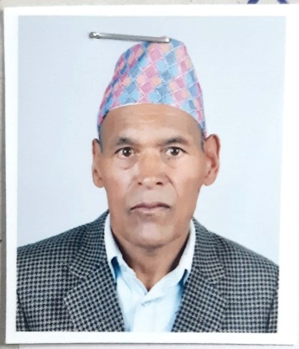Ambar bahadur Manandhar (cancer) dolakha | 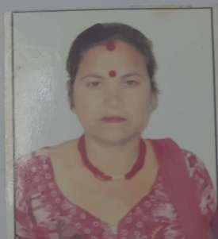  anita pariyar  cancer  Mahottari | 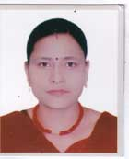  Apsara gautam  (Cancer)  kathmandu | 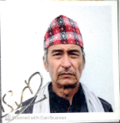  Bal Dhoj Yonjan  Cancer  Sindhuli
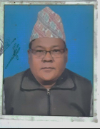  Bhim Bahadur Maharjan (Cancer)  Kathmandu | 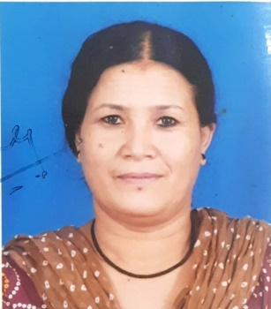  Durga Maharjan  cancer  Lalitpur | 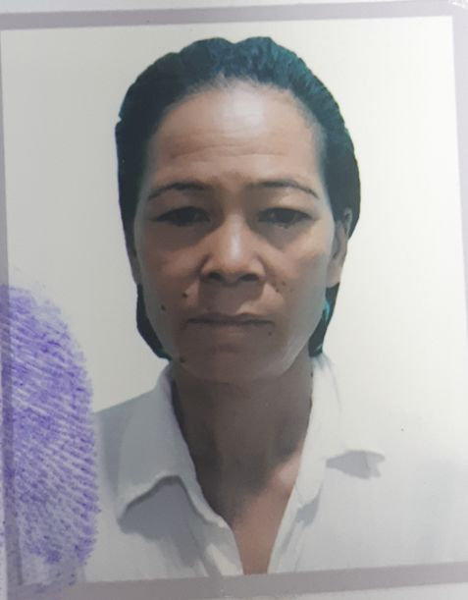  Gita Shrestha  Cancer  Kavrepalanchowk | 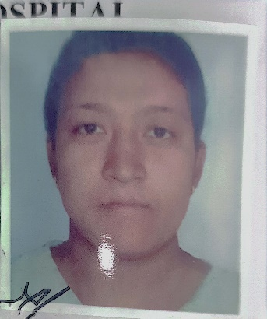  Hira Sunar  Cancer  Gorkha
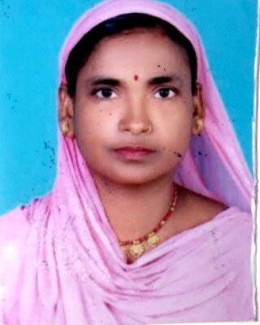  Johra Khatoon  Cancer  Dhanusha  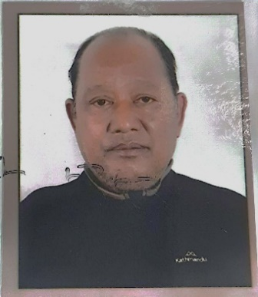  Prajendra Das Hada  (cancer)  Morang | 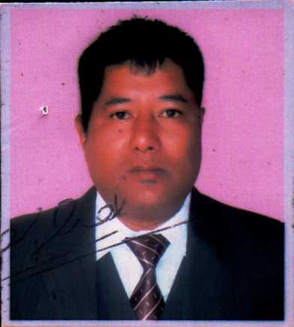  Keshab Narayan Shrestha(cancer)  Lalitpur  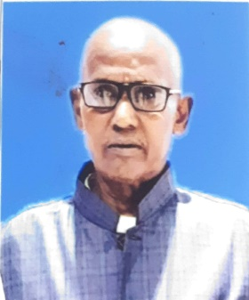  Ram singh Tharu  Cancer  Bardiya | 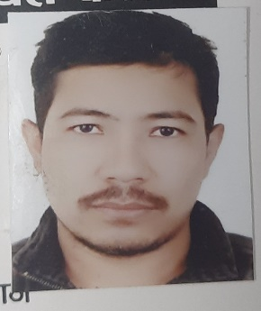  Khemraj Bajracharya  Cancer  Kathmandu  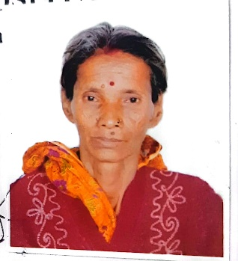  Ram kumara Devi  Cancer  Mahottari | 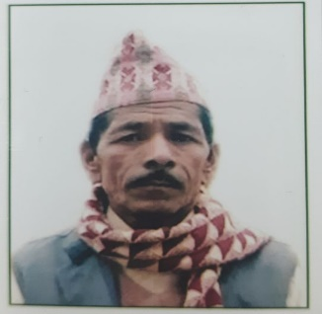  Krita Bahadur Bishwokarma  Cancer  Udayapur  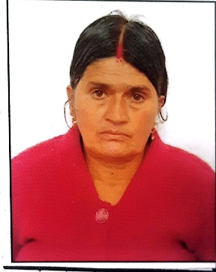  Saraswati Sanjel  Cancer  Lalitpur
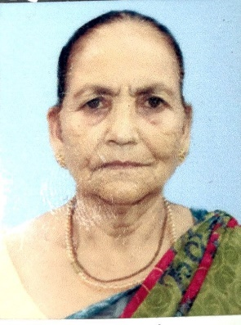  Saraswati Pradhan  Cancer  Jhapa | 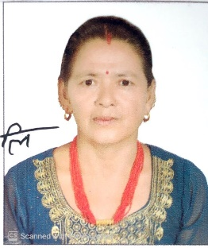  Chhali maya ghalan  (Cancer)  kavrepalanchowk | 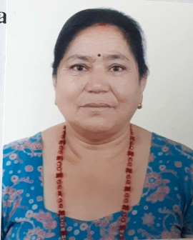  Nani Maya Maharjan  Cancer  Lalitpur

BIPANNA HEART PATIENT OF SHRAWAN 2081
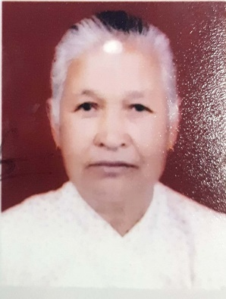  Ghana Laxmi Shrestha  Heart  Lalitpur | 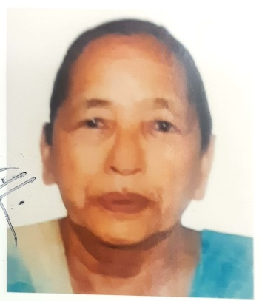  Durgi Maya Shrestha  Heart  Chitwan | 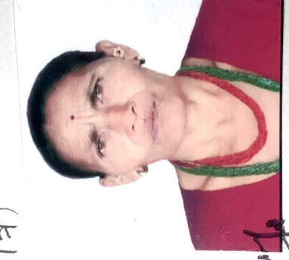  Lila Maya Shrestha  Heart  Ramechhap | 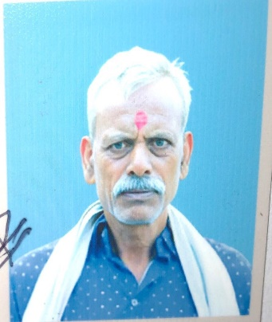  Ram Bhakti Ray Yadav  Heart  Sarlahi

